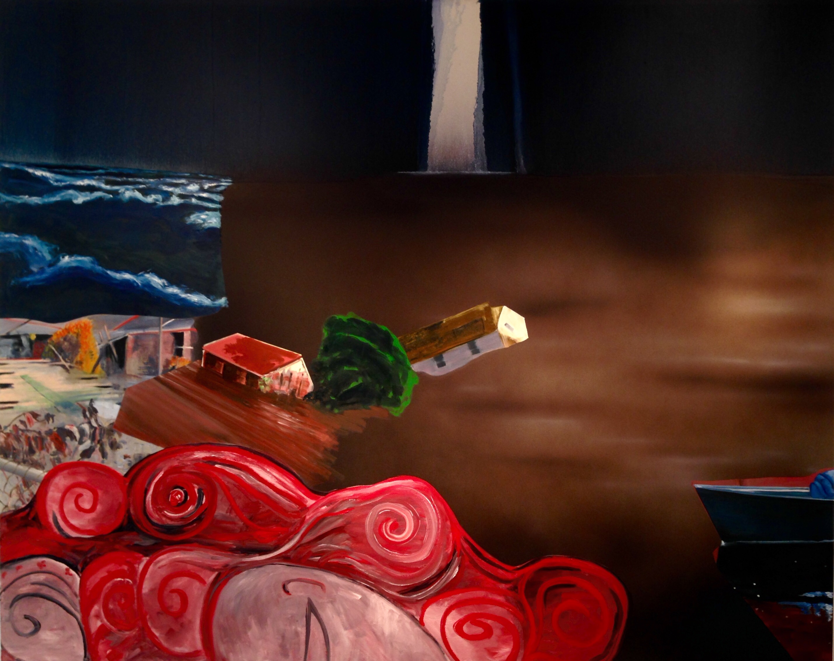
The Deluge II, 2006, oil on canvas, 78 3/4 x 98 1/2 in.

DEXTER DALWOOD: Notions of Nostalgia
September 11 – November 13, 2015

The Alan Koppel Gallery presents the work of Dexter Dalwood, British punk-rock bassist turned painter whose fusion of postmodern and classical genres defies definition. Dalwood’s large-scale, painted collages depict curated, often dream-like spaces that memorialize people, places and moments in history. Many of his works recall violent or traumatic events, such as war, celebrity death, crimes and natural disasters. Dalwood represents his pluralist view of history by deconstructing (collage) and reconstructing (painting) details of biography, hearsay and myth, while purposefully omitting the subject itself. In this way Dalwood is able to glimpse into the subjectivity of his theme, thus breaking and re-entering into a particular historical space via the present.

Dalwood’s landscapes and interiors frequently give titular reference to their absent subjects, such as Kurt Cobain’s Greenhouse (2000)— an empty, tropical vision of the late singer’s site of suicide—and Manderley (2009), a triptych nightmare of the fictitious sea-side mansion where Daphne du Maurier’s novel Rebecca (1938) and Alfred Hitchcock’s film of the same title (1940) is set.
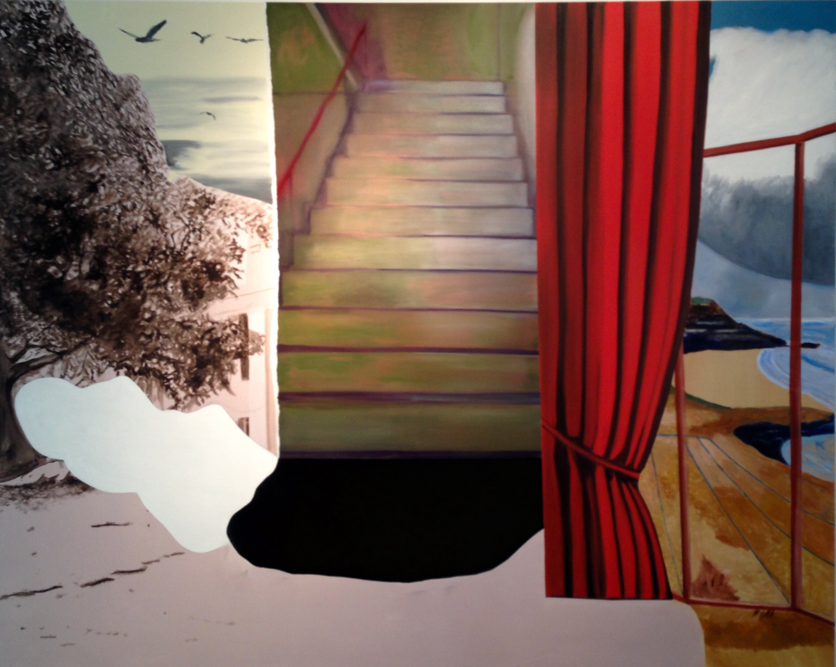
Manderley, 2009, oil on canvas, 78 11/16 x 98 3/8 in.

“I’ve always been attracted to the idea that… you can put the world together by writing it down, tearing it up and reassembling it.”
Dalwood is refreshingly unabashed when it comes to conversing with and questioning history; he integrates popular motifs from an astounding range of art historical styles, enriching his pieces with allusion and intertextuality. His artistic process of creating small-scale collages from torn magazines and art history journals before painting, for example, is a homage to the “cut-up” technique popularized by Jean-Luc Godard’s films, William Burroughs’s writing, and David Bowie’s lyrical compositions. Dalwood explains: “I’ve always been attracted to the idea that… you can put the world together by writing it down, tearing it up and reassembling it.” The four artworks on display at the Alan Koppel Gallery do just that, paying tribute to writer W.G. Sebald’s fatal accident in Crash (2008), exploring the haunting memory of the murdered mistress of the house in Manderley (2009), and capturing vibrant, fragmented flashbacks from Hurricane Katrina in The Deluge II (2006) and The Calm (2007). Dalwood’s singular talent lies in his ability to tactfully avoid false notions of nostalgia, confronting instead the subjective process of situating the present into a larger thread of cultural and historical narrative.

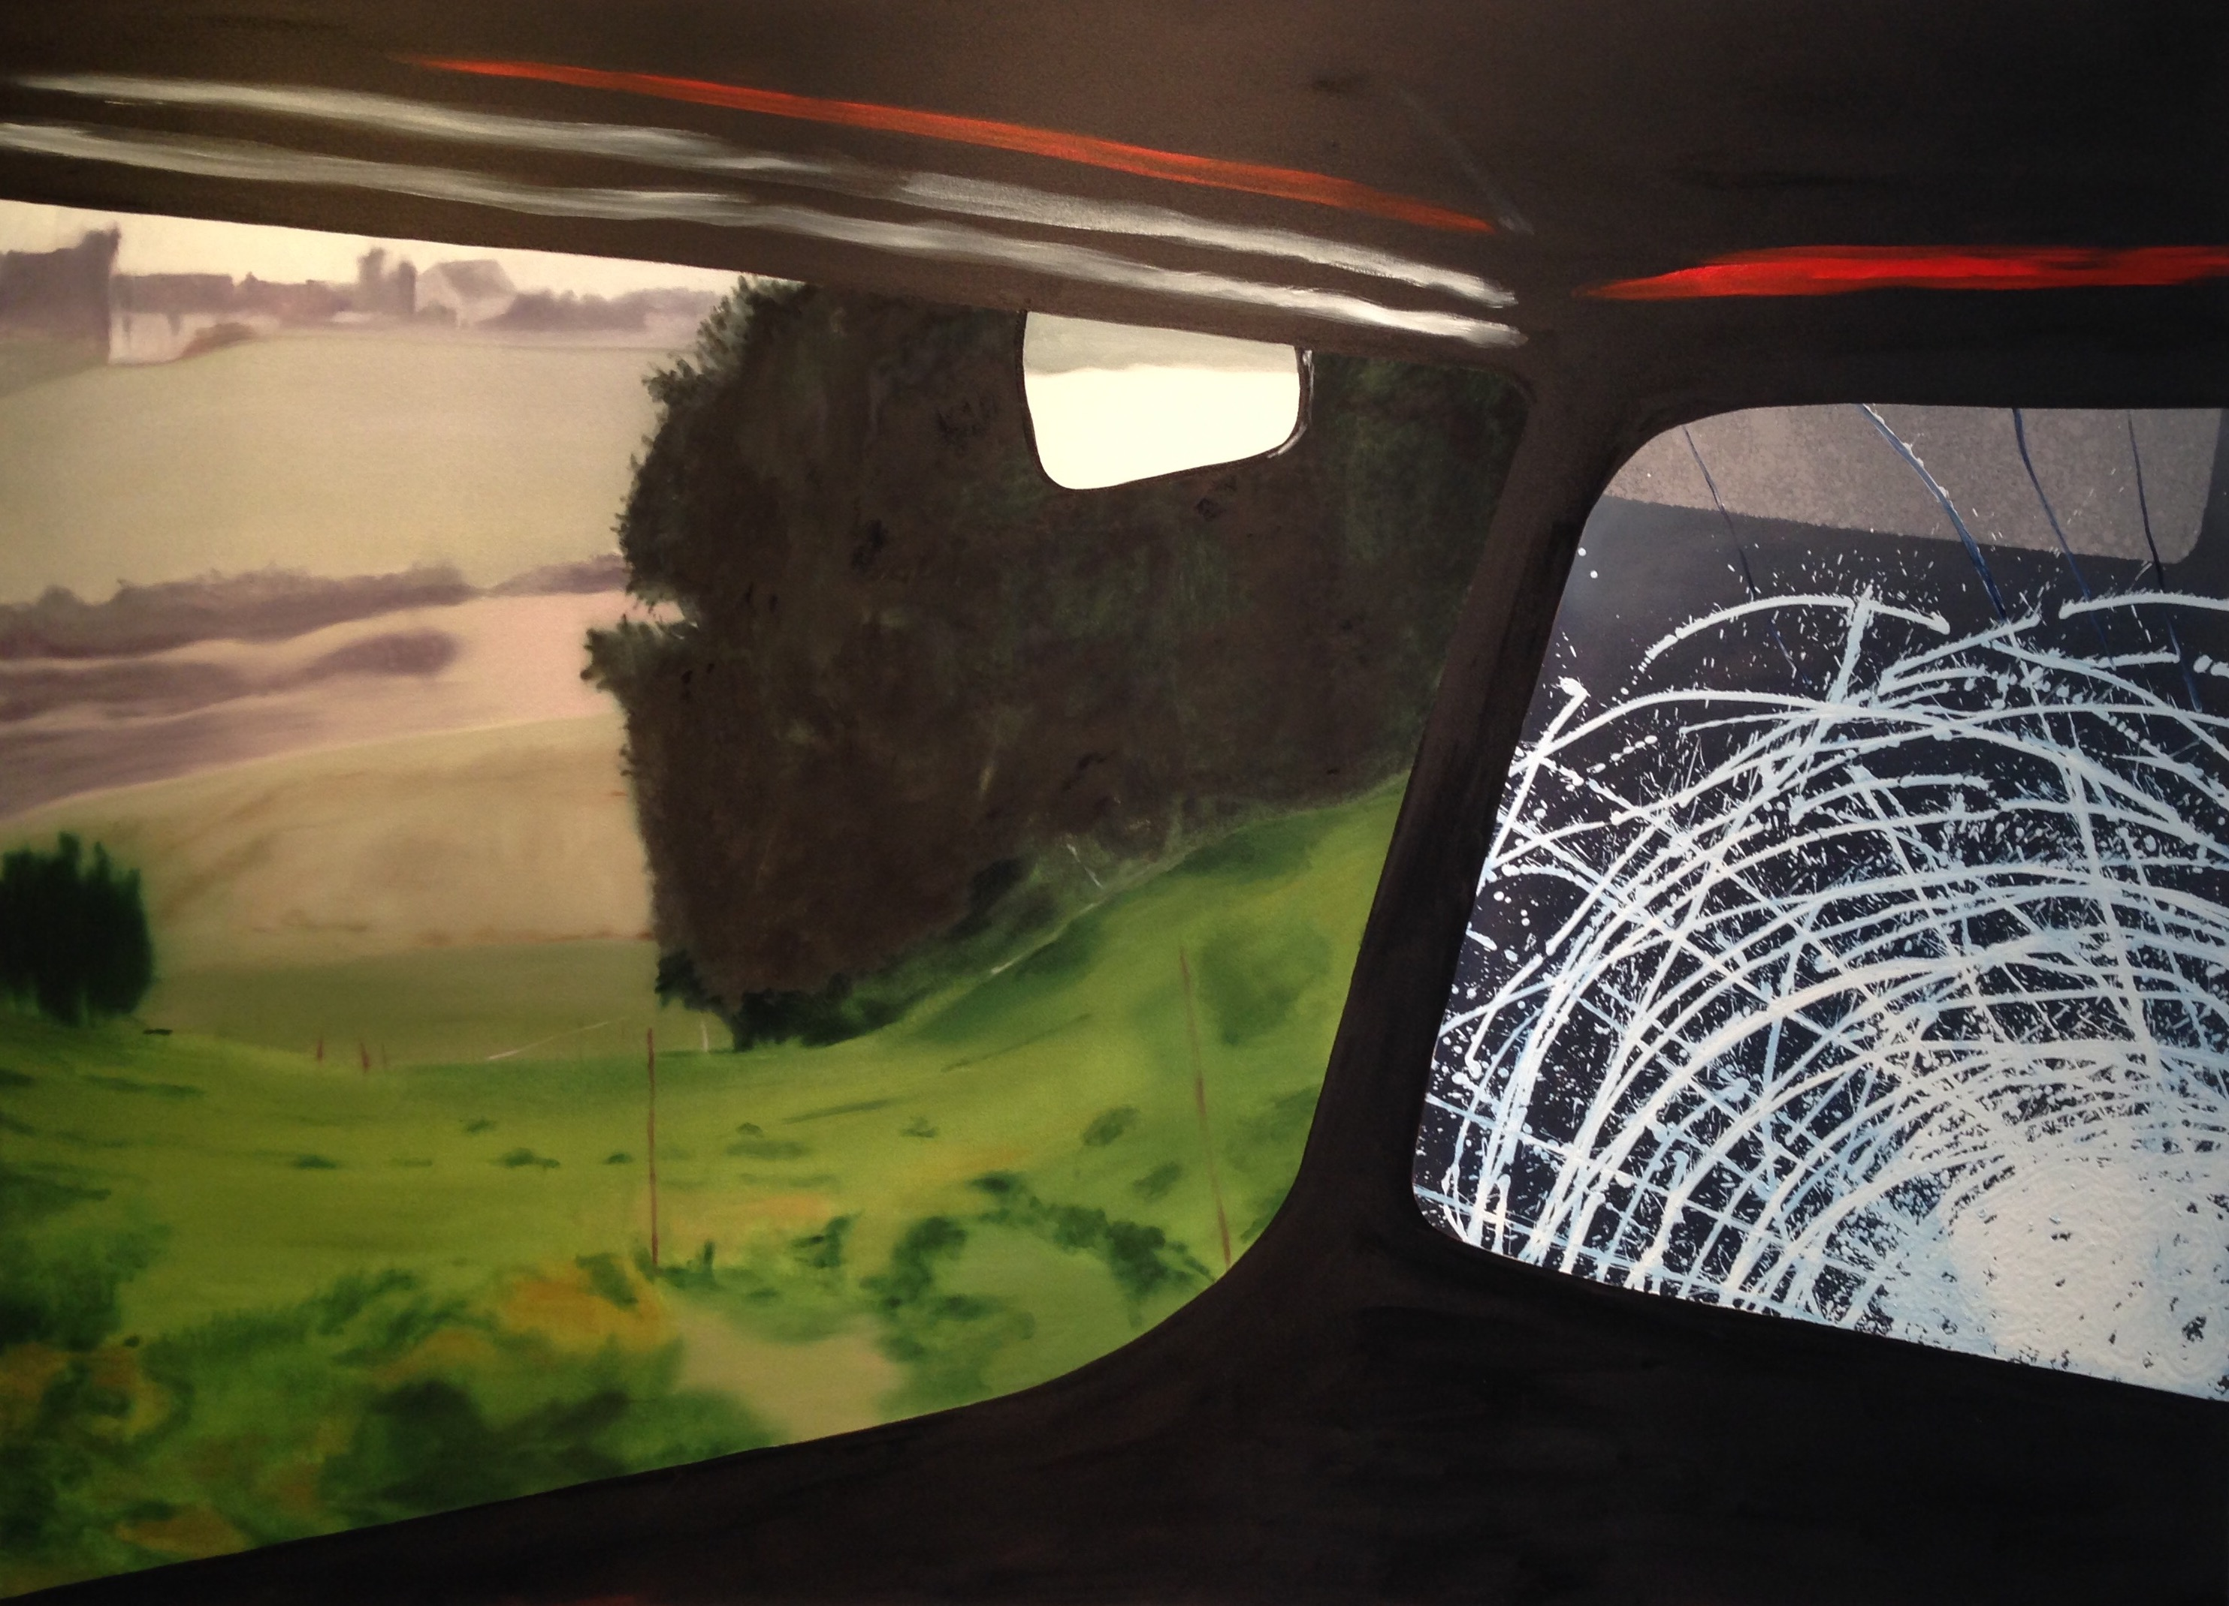
Crash, 2008, oil on canvas, 59 x 81 1/2 in.

Dexter Dalwood (b. 1960, Bristol, UK) studied at St Martins School of Art and Design, and the Royal College of Art. Recent solo exhibitions include Kunsthaus Centre d’art Centre PasquArt, Biel, Switzerland (2013); Orientalism, David Risley Gallery, Copenhagen, Denmark (2012); Dichter und Drogen, Nolan Judin, Berlin, Germany (2011) and a major solo exhibition at Tate St Ives (2010), which toured to FRAC Champagne-Ardenne, Reims, France and CAC Malaga, Spain. His work is included in the Fighting History exhibition at Tate Britain (2015). Recent group exhibitions have included The Venice Syndrome – The Grandeur and Fall in the Art of Venice, gL Holtegaard, Denmark (2014), Not Being Attentive I Notice Everything: Robert Walser and the Visual Arts, Aargauer Kunsthaus, Aarau, (2014); Le Corps de l'Absence, FRAC Champagne Ardennes, Reims, Setting the Scene, Tate Modern, London (2012) and Dublin Contemporary (2011). He has work in numerous public collections, including: Tate, The British Council Collection and The Saatchi Gallery. In 2010 Dalwood was shortlisted for the Turner Prize. He lives and works in London.
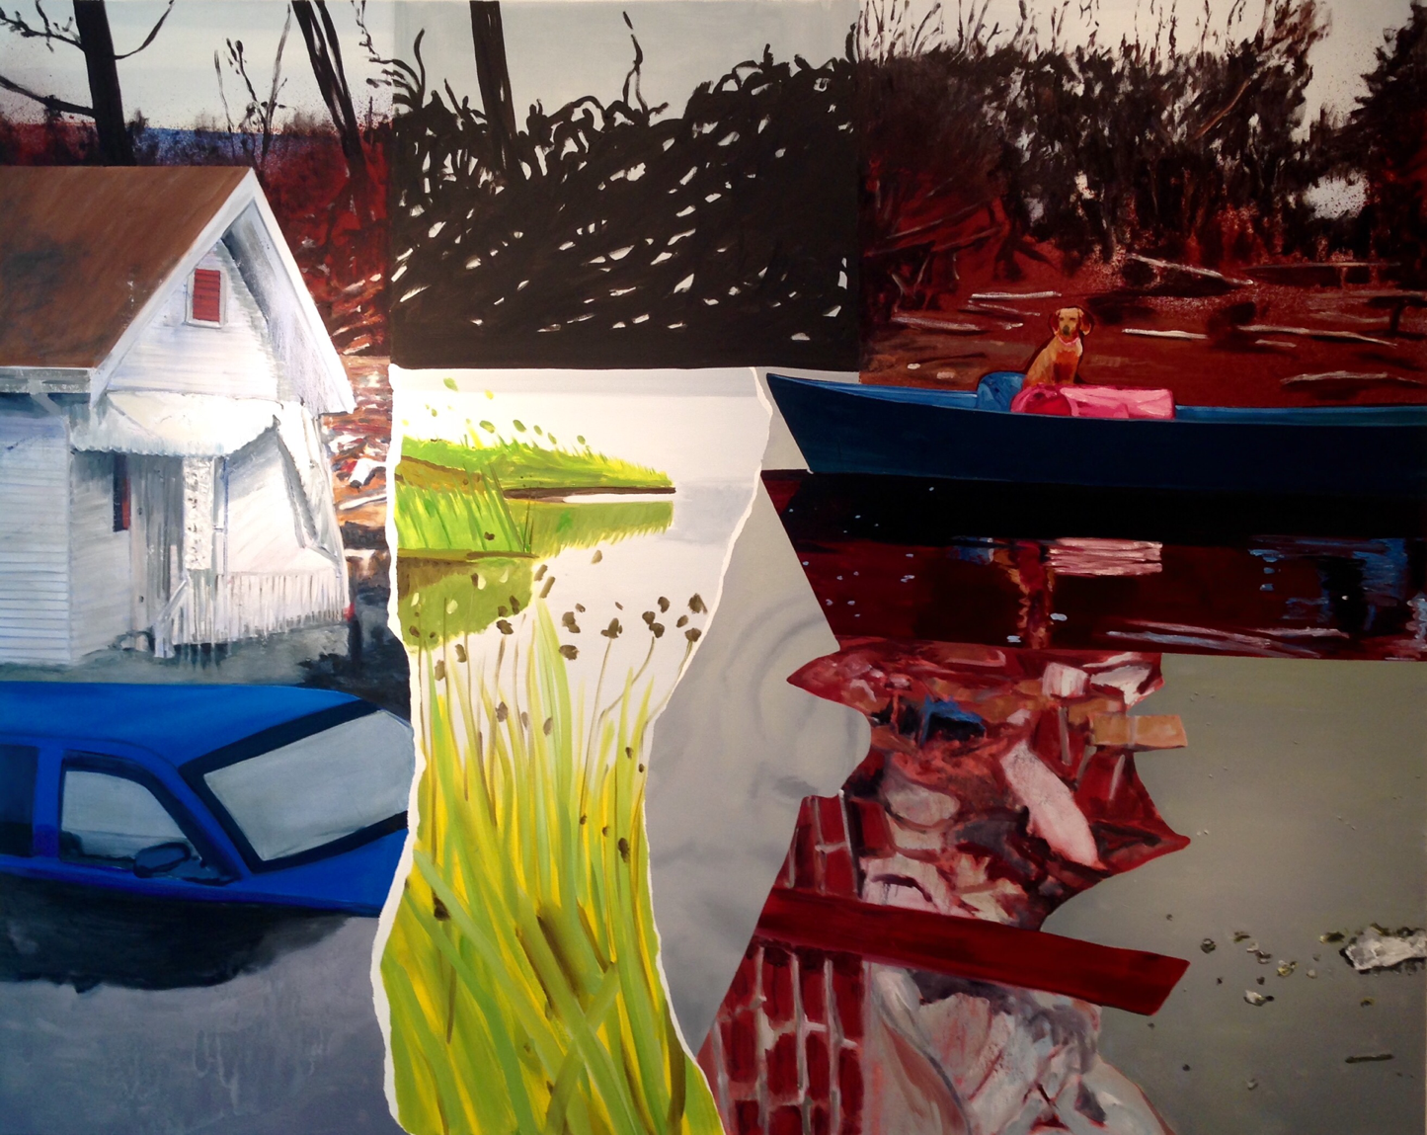
The Calm, 2007, oil on canvas, 78 3/4 x 98 1/2 in.

For further information please contact alankoppel@alankoppel.com or call (312) 640-0730. Hours of operation are Monday–Friday, 10AM–5:30PM and Saturday by appointment only.

